careers.wa.gov
Working for Washington State
How to Navigate the Job Opportunities Page

You may jump to the section you want to view by clicking on the link in the list below. You may need to hold down your keyboard ‘Ctrl’ (Control) button at the same time you click on the link.

Menu
Sign In
Search for Jobs
View a Posting

Share a Posting
Apply
Update Your Contact Information
View Applications or Postings You’ve Applied to
Continue an Application

Menu
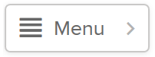
Click on the Menu option in the upper left corner of the page for quick links to helpful information.

- Careers.wa.gov – Home the main careers page.
- State of Washington Job Opportunities is the job search page.
- Get Job Alerts by sign up to be notified via email when a job posting opens in a specific job category.
- Veterans’ Information contains helpful information for veteran’s applying for state jobs.
- Quick Tips on applying for state jobs.
- Find Jobs at Colleges and Universities to broaden your job search within Washington State.
- Learn About State Agencies to access agency websites.
- Help & Support using the online application system.

Back to First Page

Sign In
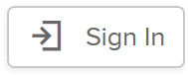
By clicking on the Sign In button in the upper right corner, you can sign into your account OR create a new account.
If you have forgotten your user username or password, click on the appropriate link and follow the instructions to retrieve.
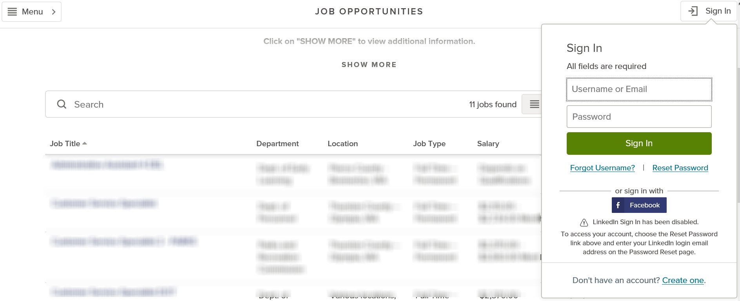

Back to First Page

Search for Jobs

KEY WORD SEARCH
Type in a key word or phrase in the Search box.
Beginning typing in the word, options will appear to click on or you may continue to type in the word and then click on the magnifying glass or click on the ‘Enter’ key on your keyboard.
In this example, the word “Accounting” was being typed in. Current job postings with the Category of Accounting and Finance and job postings with titles containing “accounting” appear.
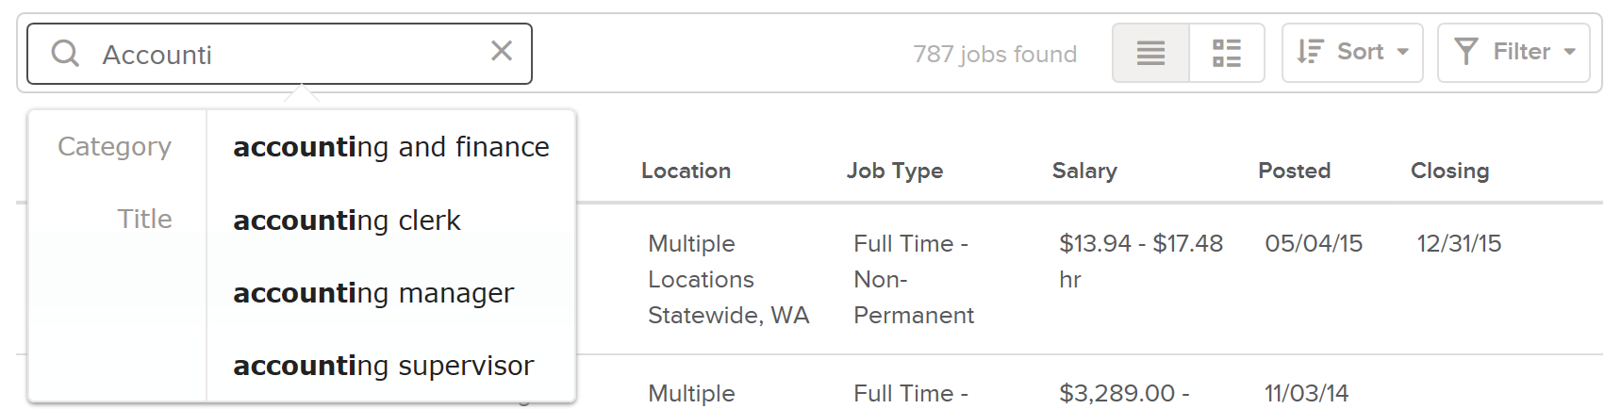
To clear the text search, click in the x in the Search box.
SORT
Use the Sort option to view jobs by when they were posted, alphabetical by job title, or salary range.
Click on Sort to view the options.
The options will fly out from the side of the page. The Sort default of Job Title A-Z will automatically be selected.
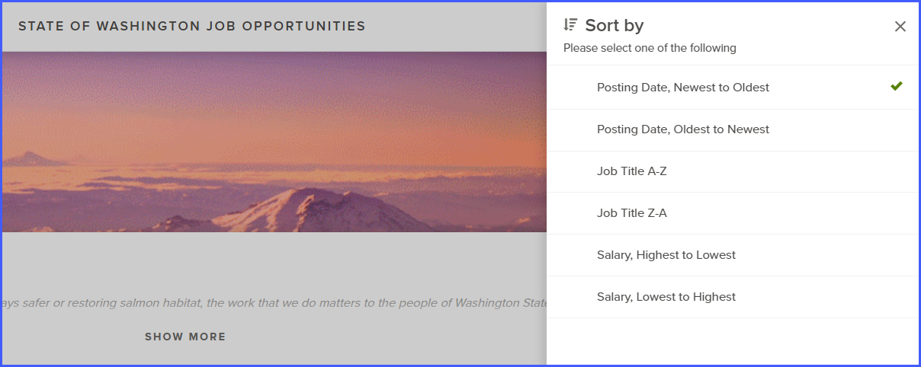
Click on option within the Sort to select.
In this example, the Posting Date, Newest to Oldest has been selected.
When you make your selection, the Sort option will automatically be applied and the job postings will be sorted in the order you selected.
FILTER
The Filter option allows you to view job jobs by Location, Remote, Department (state agency), Job Category, Job Type, and/or Estimated Annual Salary. You may select as many or as few filter options as you wish. The more filters you add, the less results will be returned in your search.
Click on Filter to view the options.
The options will fly out from the side of the page.
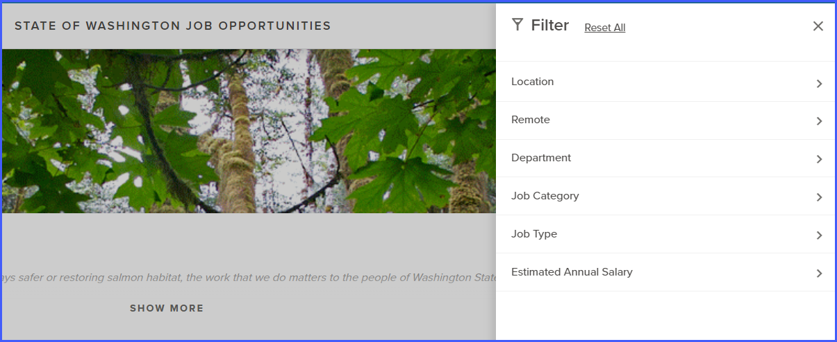
Click on the Filter category (Location, Remote, Department, Job Category, Job Type, and/or Estimated Annual Salary) to view the options within the category.
Click on the box next to each selection that you would like to filter. As selections are made, the search results are narrowed down to include only those selections.
Click on the X to close the filter and view your results.
In this example, the Location category was clicked on. All locations with a current job posting appear. The search results will include all postings in which the creator of the job posting selected the Location for the job posting to appear. Two of the locations were selected in the example below.
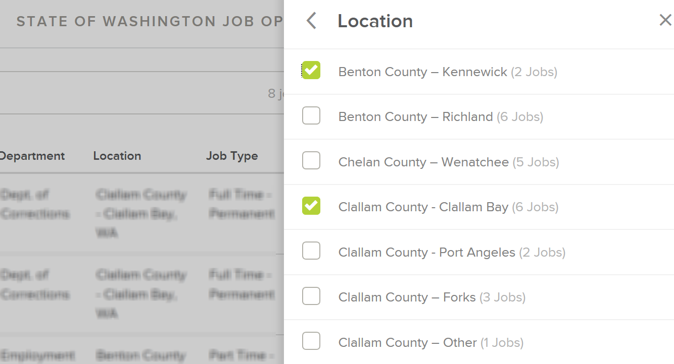
To choose multiple filters, open a filter category (e.g., Location) and click on the checkbox next to each location you want to filter on. To add additional filters, click on the arrow pointing to the left < and choose another filter category. Repeat until you have all of the filters you would like to use.
In this example, 5 Locations were selected, 3 Departments, 3 Job Categories, and 1 Estimated Annual Salary.
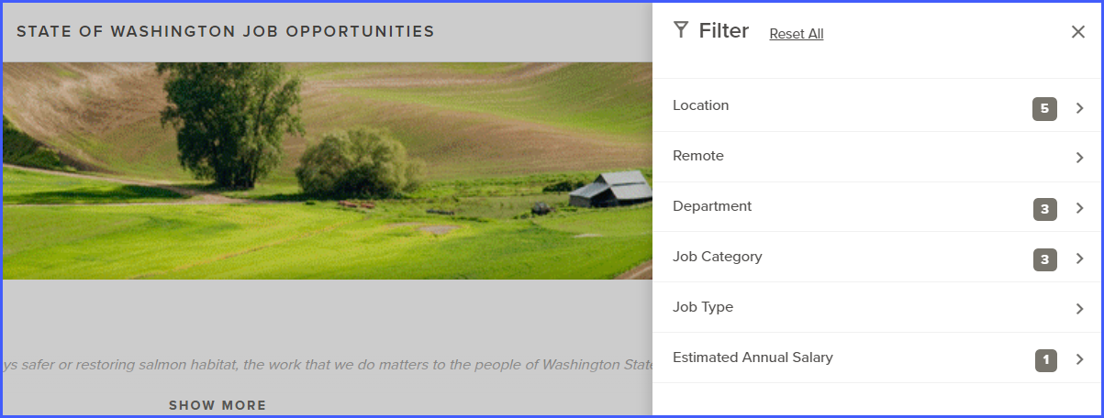
Click the X to close the filter and view your results. The results will contain only those current job postings that meet all of the filters that you selected. This narrows down your search results. To view more job postings, use less filters.
To edit the filters selected - click on Filter, and then each of the categories again. Uncheck the box next to any of the selections that you no longer want to use.
To reset all of the filters - click on Filter, and then click on Reset All.

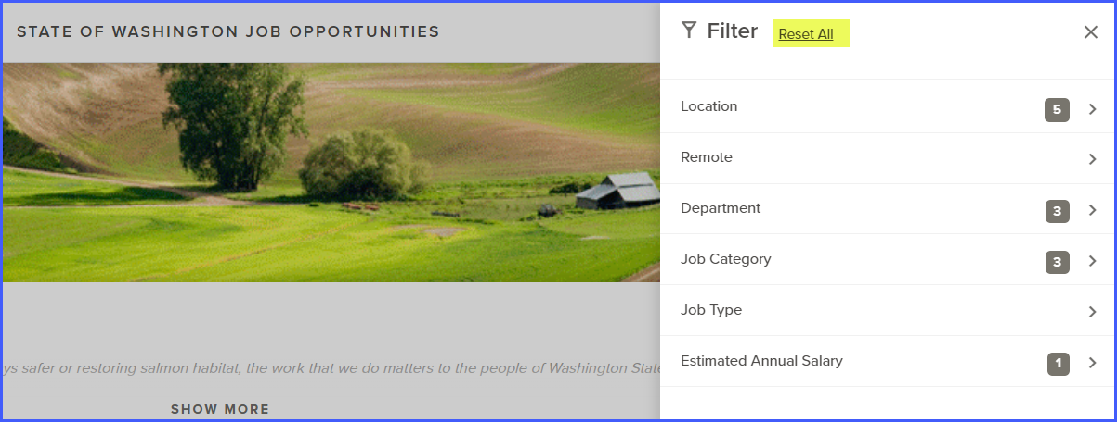

Back to First Page

View, Share, and Apply to a Job Posting

VIEW A POSTING

Click on the job posting title to view the job details. The posting will fly out from the right side of the page.
Options appear at the top of the posting.
- The < and > are navigation options to view the previous (<) or next (>) posting.
- The printer icon allows you to print the posting.
- You may use the social media options to share the posting on LinkedIn, Twitter, or Facebook.
- The envelope icon allows you to share the posting via email.
- Click on APPLY to apply for the posting.
- The X will close the posting and return you to the careers page.
In the next section of the posting, you may see the posting title, Salary, Location, Job Type, Department (agency), Job Number, if the position is remote eligible, and when the posting is scheduled to close.
The posting will display with in the DESCRIPTION section, which typically includes an overview of the agency where the vacancy is located, the job duties, requirements, and contact information for the recruiting agency.
Click on BENEFITS to view Washington State’s standard benefits statement. The benefits described in this section are typical for full-time employees who are expected to work more than six months. Actual benefits may vary by appoint type or be prorated for other than full-time work.
If the posting has supplemental questions, you can preview them by clicking on QUESTIONS. You will need to click on Apply and log into your account before you may submit your application or enter your response to the questions that appear. You may want to review the questions and prepare your responses prior to clicking on Apply.
In this example, the job posting is for an LPN2 pool of applicants and will be used to fill vacancies throughout the state. The DESCRIPTION option is underlined because it is selected.
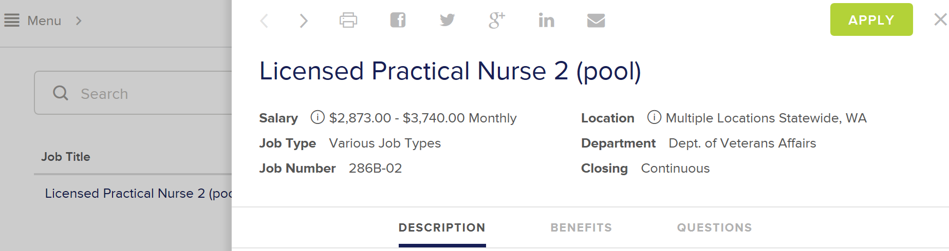

SHARE A POSTING

Use the social media options at the top of the posting to share the posting. Click on the icon to log into your social media account to share the posting.

Share on your Facebook account.

Tweet from your Twitter account.
Show on your LinkedIn account.

APPLY
Click on the APPLY button that appears in the upper right corner. If you do not see an APPLY button, read the job posting for application instructions.
Enter your Username or Email address and Password, and then click on Sign In if you are a returning user.
- If you created your account by using your Facebook profile, then click on the corresponding icon and follow the instructions that appear to log into your application account. Note: the option to create a new account and logging on using your LinkedIn credentials is no longer available due to changes in LinkedIn’s policy. If you originally created your account using your LinkedIn credentials, click on the Reset Password link and enter your LinkedIn login email address on the Password Reset page.
Click on Create an Account if you are a new user.
- Optional - You may create an account using your Facebook profile by clicking on the corresponding icon and following the instructions that appear.
- By clicking on the eye icon in the Password field, you may view your password as you’re typing it in.

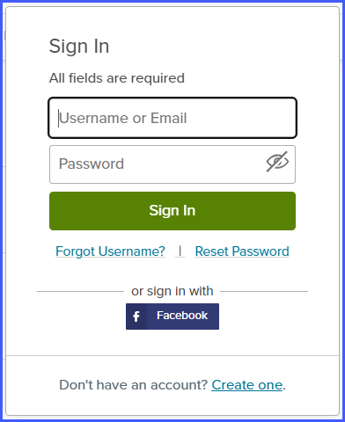

Want to read the job posting again? Click on Job Details.
If you click on Support, you will be taken to the governmentjobs.com Online Employment Application Guide. This guide will provide general process information.
Back to First Page

Update Your Contact Information
Click on Sign In in the upper right corner of the page. Enter in your Username or Email address and Password, click on Sign In.
Click on your name in the upper right corner.
Click on Account from the options that appear.

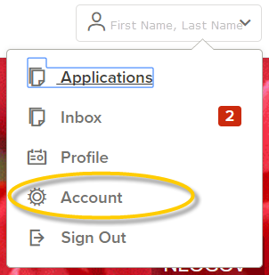
Click on the Edit icon.
Make the changes needed and click on Save at the bottom of the page.

Back to First Page

View Applications or Postings You Applied To
Click on Sign In in the upper right corner of the page. Enter in your Username or Email address and Password, click on Sign In.
Click on your name in the upper right corner.
Click on Applications from the options that appear.

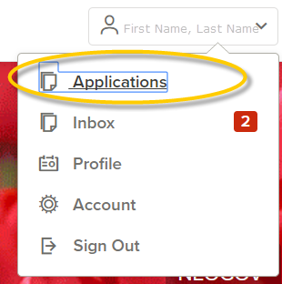
You will be taken to your Applications page with the SUBMITTED applications option selected.
Click on the job posting title. Your application information will fly out from the side of the page.
With Application selected, you can view your application information or click on the print icon to print your application.
In this example, Application is identified as selected because it is underlined.
Click on Job Details to view the job posting.
In this example, Job Details is identified as selected because it is underlined.
Back to First Page

Continue an Application
Click on Sign In in the upper right corner of the page. Enter in your Username or Email address and Password, click on Sign In.
Click on your name in the upper right corner.
Click on Applications from the options that appear.

You will be taken to your Applications page with the SUBMITTED applications option selected. Click on INCOMPLETE.
Back to First Page

[End of document]

